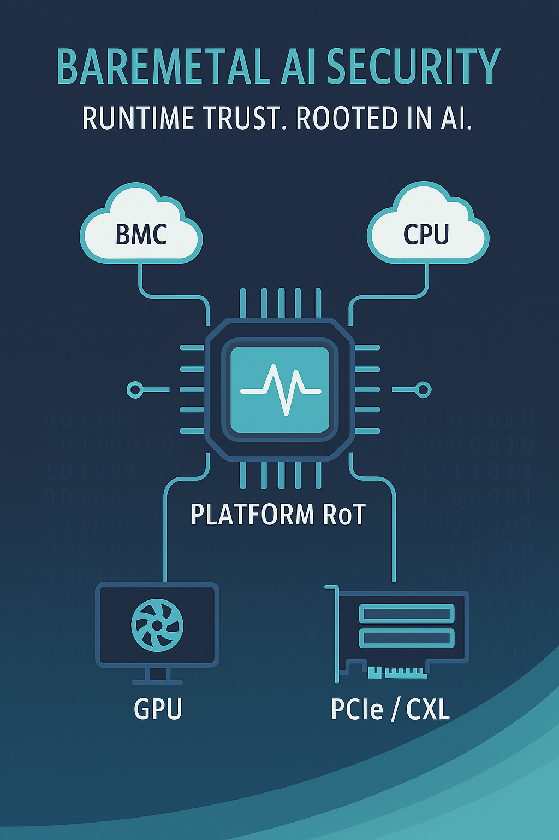  baremetal ai enhanced security  Specification Rev 0.1 | Abstract  [Draw your reader in with an engaging abstract. It is typically a short summary of the document. When you’re ready to add your content, just click here and start typing.]  Suresh Marisetty  CTO

Extending Platform Trust: AI-Augmented Bare Metal Security Across PSA Level 3, Caliptra RoT, CXL, and TDISP
Executive Summary
This specification introduces a modular, AI-enhanced architecture for bare metal security in cloud platforms. Building on PSA Level 3 and Caliptra Root of Trust, it distributes AI agents across Platform RoT, BMC, Host CPU, GPU, and PCIe/CXL devices. These agents collaborate via SPDM, TDISP, and secure telemetry channels to detect anomalies, enforce policies, and extend trust across disaggregated fabrics.
1. Background and Motivation
- PSA Level 3 and Caliptra RoT provide secure boot, attestation, and lifecycle anchors.
- Runtime threats—firmware abuse, side-channel attacks, rogue DMA—require continuous observability.
- AI enables scalable anomaly detection, federated learning, and adaptive trust enforcement.
- CXL and TDISP introduce new trust boundaries across memory and device fabrics.
2. System Components and Roles
Component | RoT Role | SPDM Role | AI Capability Location
Platform RoT (PA RoT) | Immutable RoT | SPDM Requester | Central AI orchestrator, policy engine
BMC | Extended RoT | SPDM Responder | Firmware integrity, lifecycle monitoring
Host CPU | Extended RoT | SPDM Responder | Boot validation, syscall anomaly detection
GPU / Accelerators | Extended RoT | SPDM Responder | ECC monitoring, model drift detection
PCIe/CXL Devices | Extended RoT | SPDM Responder | DMA audit, config space integrity

3. AI Distribution and Collaboration Model
- Platform RoT coordinates federated learning and policy enforcement.
- Responders run lightweight AI agents for local anomaly detection.
- SPDM provides attestation and transcript logging.
- Telemetry is streamed via MCTP/PLDM or DOE.
- TDISP enforces secure protocol behavior across PCIe/CXL links.
4. Telemetry Schema per Component
Component | Key Telemetry Signals
Platform RoT | SPDM transcripts, trust status, policy logs
BMC | Firmware hashes, IPMI logs, sensor anomalies
Host CPU | Boot logs, syscall traces, memory access patterns
GPU | ECC errors, floating-point anomalies, power traces
PCIe/CXL | DMA logs, config snapshots, IDE stream status

5. Threat Mapping and AI Detection Coverage
Threat Category | AI Detection Role
Software Integrity | Boot pattern analysis, firmware hash validation
Storage Protection | Access pattern anomaly detection
Interface Exploits | Mailbox fuzzing, debug traffic analysis
Crypto Weakness | Entropy analysis, impersonation detection
Side-Channel Attacks | Timing/power anomaly detection
Fault Injection | Voltage/clock glitch signature recognition

5. Standards Alignment: PSA Level 3, Caliptra RoT, and OCP S.A.F.E
TrustForgeAI’s architecture is designed to align with the most rigorous platform security standards across cloud, embedded, and hyperscale environments. Our modular RoT implementation leverages Caliptra and supports conformance with both PSA Certified Level 3 and OCP S.A.F.E..

🧱 PSA Level 3: Embedded Assurance
PSA Certified Level 3 provides penetration-tested assurance for embedded platforms, covering:
- Secure boot and firmware update flows
- Cryptographic key isolation and attestation
- Threat modeling and lifecycle management
- Compliance with SESIP and GlobalPlatform APIs
TrustForgeAI’s RoT modules are engineered to meet PSA Level 3 requirements, enabling secure provisioning, telemetry, and federated trust across constrained devices.
🏢 OCP S.A.F.E.: Hyperscale Firmware Transparency
OCP S.A.F.E. (Security Appraisal Framework and Enablement) complements PSA by focusing on:
- Firmware and microcode integrity for server-class components
- Secure update mechanisms and rollback protection
- Manual code inspection by approved Security Review Providers (SRPs)
- Open-source alignment and GitHub-based review artifacts
TrustForgeAI’s telemetry and runtime trust orchestration are designed to integrate with OCP S.A.F.E. workflows, enabling hyperscale operators to validate firmware provenance and runtime behavior.
🔗 Caliptra RoT: Silicon-Rooted Trust
Caliptra provides a silicon-based Root of Trust with:
- Secure boot, measurement, and attestation
- Integration with DICE and SPDM protocols
- Compatibility with both PSA and OCP S.A.F.E. assurance models
TrustForgeAI extends Caliptra’s capabilities with modular telemetry hooks and federated learning support, enabling runtime trust across diverse platform segments.

🧠 Strategic Convergence
By aligning with both PSA Level 3 and OCP S.A.F.E., TrustForgeAI bridges the assurance gap between embedded and hyperscale platforms. This dual conformance enables:
- Unified trust posture across cloud, edge, and automotive domains
- Reduced audit overhead for hyperscalers and OEMs
- Transparent, standards-driven security for modular RoT deployments
6. Alignment with PSA Level 3 and Caliptra
PSA/Caliptra Layer | AI Enhancement Role
Secure Services | Attestation, key management observability
Firmware RoT | Boot sequence validation, manifest integrity
Hardware RoT | Sensor monitoring, physical tamper detection
Lifecycle Anchors | Provisioning, update validation, decommissioning
SPDM Protocol | Identity exchange, transcript logging

7. Integration of CXL and TDISP
Component | CXL/TDISP Role | AI Role
Platform RoT (PA RoT) | CXL root complex, TDISP policy enforcer | AI policy hub, federated model coordinator
BMC | TDISP-aware provisioning and attestation | Firmware integrity, lifecycle monitoring
Host CPU | CXL host interface, memory guard | Boot validation, syscall anomaly detection
GPU / CXL Type 1/2 | TDISP endpoint | ECC monitoring, model drift detection
Smart Memory / CXL.mem | TDISP endpoint | Version freshness, memory access audit
PCIe Switches | IDE stream integrity | DMA audit, replay detection

8. Modular Code Components for UEFI and SMM
Module Name | Purpose | Integration Targets
SPDM Transcript Logger | Capture and verify SPDM exchanges | Platform RoT, UEFI DXE, SMM handler
AI Telemetry Collector | Aggregate runtime signals | All RoT components, DXE, SMM
Manifest Validator | Validate firmware manifests | Host CPU, GPU, PEI/DXE, SMRAM
Lifecycle Anchor Manager | Track provisioning and updates | BMC, Platform RoT, Capsule monitor
TDISP Policy Enforcer | Enforce stream isolation and replay guard | PCIe/CXL endpoints, DXE, SMM
Boot Sequence Profiler | Analyze boot flow integrity | Host CPU, PEI/DXE, SMM snapshot
ECC & Drift Monitor | Detect GPU memory corruption | GPU, DXE, SMM
Secure DMA Auditor | Monitor PCIe DMA patterns | PCIe endpoints, DXE, SMM

9. Additional Modular Enhancements for UEFI and SMM
Enhancement Module | Purpose
Runtime Policy Engine | Enforce AI-derived security policies during boot/runtime
Secure Event Journal | Append-only log of security events with TPM sealing
Entropy Quality Monitor | Validate RNG entropy sources and health
Firmware Behavior Profiler | Trace execution paths and detect deviations
IDE Stream Validator | Monitor IDE/TDISP stream setup and integrity
Update Provenance Verifier | Validate firmware update origin and freshness
SMRAM Guard Monitor | Detect unauthorized SMRAM access attempts
Caliptra Mailbox Proxy | Expose Caliptra telemetry to UEFI/SMM
Federated Learning Agent | Participate in model training during boot
TDISP-Aware Device Filter | Enforce device access policies based on TDISP stream status

10. Implementation Strategy
- Language: C/C++ (EDK2), Assembly/C (SMM)
- Packaging: Modular libraries with defined APIs
- Testing: QEMU/OVMF, Intel SDE, Chipsec
- Security: SMRAM isolation, stack canaries, hardened memory access
11. Standardized Telemetry Schema
Core Object Structure
json
{
"component_id": "host_cpu_01",
"timestamp": "2025-10-28T10:59:00Z",
"firmware_version": "1.2.3",
"boot_phase": "DXE",
"telemetry_type": "runtime",
"trust_state": "attested",
"metrics": {
"ecc_errors": 2,
"dma_anomalies": 0,
"syscall_outliers": 5,
"entropy_quality": 0.92,
"tdisp_stream_status": "valid"
},
"events": [
{
"event_id": "evt_001",
"event_type": "manifest_validation",
"severity": "warning",
"details": "Version freshness check failed"
}
],
"attestation": {
"spdm_transcript_hash": "abc123...",
"tdisp_nonce": "xyz789...",
"pcr_values": {
"0": "hash0",
"1": "hash1"
}
}
}

📡 Overview of OpenBMC Telemetry
OpenBMC telemetry is designed to expose platform metrics in a structured, vendor-neutral format. It enables system administrators and orchestration tools to monitor hardware health, performance, and environmental conditions across server platforms.

🔧 Core Capabilities
- Sensor Aggregation: Collects and organizes data from onboard sensors (e.g., temperature, voltage, fan speed).
- Metric Reports: Supports on-demand creation of metric reports—grouped sets of sensor values.
- Push and Pull Models:
  - Pull: Clients can query metrics via Redfish API.
  - Push: Metrics can be streamed or triggered based on thresholds or events.
- Redfish TelemetryService Integration: Implements the Redfish TelemetryService schema for standardized access and interoperability.
- Runtime Monitoring: Continuously tracks sensor updates and system state changes.

📦 Implementation Details
- Telemetry Middleware: Written in C++ with Meson build system; integrates with OpenBMC’s D-Bus infrastructure.
- Service File: xyz.openbmc_project.Telemetry.service defines the telemetry daemon.
- Build Options:
  - Yocto/Bitbake: For embedded builds.
  - Meson/Ninja: For native development and testing.

🔧 Hardware & Sensor Events
- Temperature threshold exceeded
- Voltage out-of-range
- Fan failure or speed anomaly
- Power supply unit (PSU) failure
- DIMM or CPU presence/health change
- NVMe or storage device errors

⚡ Power & Boot Events
- Host power on/off
- BMC reboot or crash
- Boot progress codes
- Watchdog timeout
- System reset initiated

🔐 Security & Access Events
- Failed login attempts (SSH, Redfish, IPMI)
- User account changes
- Certificate updates or revocation
- SPDM or attestation failures (if enabled)

🔄 Firmware & Configuration Events
- BIOS or BMC firmware update
- Configuration changes (e.g., network, hostname)
- Sensor calibration or reconfiguration
- Redfish schema violations or malformed requests

🧪 Diagnostic & Debug Events
- Core dumps or crash logs
- System dumps triggered
- Hardware fault isolation (guarded components)
- Callouts for service actions

OpenBMC Event Table
Event Code | Event Type | Description
0x0001 | System Boot | Host system powered on and boot sequence initiated
0x0002 | System Shutdown | Host system powered off
0x0003 | BMC Reboot | BMC firmware restarted or reset
0x0100 | Sensor Threshold Breach | Sensor reading exceeded defined threshold (e.g., temperature, voltage)
0x0101 | Fan Failure | Fan speed anomaly or complete failure detected
0x0102 | PSU Failure | Power Supply Unit fault or loss of redundancy
0x0200 | DIMM Error | Memory module error or ECC fault
0x0201 | CPU Fault | Processor health degraded or thermal event
0x0300 | Firmware Update Started | BIOS or BMC firmware update initiated
0x0301 | Firmware Update Completed | Firmware update completed successfully
0x0302 | Firmware Update Failed | Firmware update failed or was aborted
0x0400 | Watchdog Timeout | System watchdog expired, indicating hang or crash
0x0500 | User Login Failed | Failed login attempt via SSH, IPMI, or Redfish
0x0501 | User Account Modified | User account created, deleted, or modified
0x0600 | Certificate Updated | TLS or Redfish certificate replaced or revoked
0x0700 | SPDM Attestation Failure | Secure protocol attestation failed or was rejected
0x0800 | Crash Dump Triggered | System or BMC crash dump captured
0x0900 | Component Guarded | Faulty hardware component marked as guarded (e.g., DIMM, CPU)
0x0A00 | Redfish Request Error | Malformed or unauthorized Redfish API request
0x0B00 | Configuration Changed | Network, hostname, or other system config updated

Standard UEFI BIOS Event Log Flow to BMC

🧩 Typical Event Sources in UEFI
- POST codes and boot progress
- Firmware update status
- Hardware initialization errors (e.g., DIMM, CPU, PCIe)
- Secure boot violations
- Platform configuration changes
Event Code | Event Name | Description
0x3000 | BIOS Boot Initiated | BIOS has started the boot process
0x3001 | POST Completed | Power-On Self-Test completed successfully
0x3002 | Boot Device Selected | BIOS has selected the boot device
0x3003 | Secure Boot Violation | Secure Boot failed due to unauthorized firmware or configuration
0x3004 | Firmware Update Started | BIOS firmware update initiated
0x3005 | Firmware Update Completed | BIOS firmware update completed successfully
0x3006 | Firmware Update Failed | BIOS firmware update failed or was aborted
0x3007 | CMOS Battery Low | BIOS detected low voltage on CMOS battery
0x3008 | BIOS Configuration Changed | BIOS settings modified (e.g., boot order, virtualization flags)
0x3009 | BIOS Password Changed | Setup password was updated via BMC or host interface
0x300A | Hardware Initialization Error | BIOS detected fault during DIMM, CPU, or PCIe initialization
0x300B | BIOS Recovery Triggered | Recovery BIOS image loaded due to corruption or failure
0x300C | BIOS Guard Activated | BIOS Guard or similar protection mechanism triggered
0x300D | BIOS Version Mismatch | BIOS version does not match expected platform configuration

12.1 OpenBMC Telemetry Extensions for for Baremetal AI Platforms
To support federated AI platforms anchored in Caliptra RoT and PSA Certified trust models, OpenBMC can be extended to emit AI-aware events that enhance observability, attestation, and runtime assurance. These events help bridge firmware, telemetry, and orchestration layers in distributed environments like those envisioned by TrustForgeAI
 | Description
spdmTranscriptHash | SPDM attestation context
tdispStreamStatus | TDISP stream validity
anomalyScore | AI model output
featureVector | Input features for anomaly detection
policyDecision | Action taken based on AI inference

Event Name | Description | Trigger Point
FederatedNode_Provisioned | Node successfully onboarded with federated identity and trust anchor | After SPDM attestation and identity binding
AI_TelemetryAgent_Activated | Secure telemetry agent initialized and linked to RoT | During OS boot or BMC handshake
Caliptra_Attestation_Completed | Caliptra RoT attestation completed and verified | Post-boot, during SPDM/EAT exchange
AI_Model_Integrity_Verified | Hash/signature of deployed AI model verified against expected value | Before model execution
SecureInference_Engine_Initialized | Hardware accelerator (GPU/NPU) initialized with RoT-bound telemetry | During device enumeration or OS boot
FederatedTelemetry_Stream_Started | Telemetry stream securely routed to federated trust aggregator | Post-boot, after network provisioning
AI_Workload_Quarantined | Workload isolated due to failed attestation, anomaly, or policy violation | Runtime monitoring or BMC policy enforcement
RoT_Health_Degraded | Caliptra or SPDM trust anchor reported degraded status | During periodic health check or telemetry scan
SecureMemory_Region_Allocated | Memory region allocated for AI model or telemetry with RoT protection | During firmware handoff to OS
FederatedPolicy_UpdateReceived | Updated trust or telemetry policy received from federated controller

Benefits for Federated AI:
These events enable secure, standards-aligned observability across federated AI nodes, supporting runtime trust, policy enforcement, and model integrity verification. Let me know if you'd like help drafting Redfish schema extensions or visualizing this event flow across Caliptra, SPDM, and OpenBMC.
12.2 Suggested UEFI Events for Baremetal AI Platforms
To support Baremetal AI enhancements—especially in federated, RoT-anchored environments like those envisioned by TrustForgeAI—UEFI firmware can be extended to emit AI-relevant events that improve observability, attestation, and runtime assurance. These events would bridge the gap between low-level platform state and high-level AI orchestration.
Event Name | Purpose | Trigger Point
AI_Workload_Intent_Detected | Signals that the OS or hypervisor is preparing to launch an AI workload | During boot or handoff to OS
RoT_Attestation_Completed | Confirms successful attestation of platform RoT (e.g., Caliptra) | After SPDM/EAT token exchange
Telemetry_Agent_Provisioned | Indicates that AI telemetry agent has been securely provisioned | Post-boot, during BMC handshake
Federated_Node_Identity_Bound | Logs binding of federated identity to platform (e.g., via DICE or TPM) | During secure boot or attestation phase
AI_Model_Integrity_Verified | Confirms hash/signature of deployed AI model matches expected value | Before model execution
Runtime_Trust_Anchor_Activated | Indicates activation of runtime trust anchor for AI telemetry | During OS boot or agent launch
Secure_Memory_Region_Allocated | Logs allocation of memory for AI model or telemetry with RoT protection | During firmware handoff to OS
Inference_Engine_Initialized | Signals that hardware acceleration (e.g., GPU/NPU) is initialized securely | During device enumeration or OS boot
Federated_Telemetry_Stream_Started | Marks the start of telemetry stream to federated trust aggregator | Post-boot, after network provisioning
AI_Workload_Quarantined | Logs when a workload is isolated due to failed attestation or anom

12.3 Suggested RoT Event Log Extension to BareMetal AI
To support Federated AI platforms anchored in Caliptra-based Root of Trust (RoT), OpenBMC can be extended to emit and manage Caliptra-specific events that enhance attestation, telemetry, and runtime trust. These events bridge secure firmware with orchestration layers, enabling scalable observability and policy enforcement across distributed AI nodes.
Event Name | Description | Trigger Point
Caliptra_Provisioning_Started | Indicates the start of Caliptra RoT provisioning and key injection | During manufacturing or secure onboarding
Caliptra_Provisioning_Completed | Confirms successful provisioning of Caliptra RoT | Post key injection and identity binding
Caliptra_Attestation_Requested | BMC or host has initiated attestation via SPDM or EAT | During boot or telemetry handshake
Caliptra_Attestation_Successful | Attestation completed and verified by BMC or remote verifier | After SPDM/EAT token validation
Caliptra_Attestation_Failed | Attestation failed due to integrity mismatch or expired credentials | During boot or runtime trust check
Caliptra_Firmware_Measurement | Logs firmware hash or measurement extended into PCR or digest | During secure boot or firmware update
Caliptra_Telemetry_Anchor_Activated | Secure telemetry anchor initialized for runtime monitoring | Post-attestation, before workload launch
Caliptra_Health_Degraded | RoT health check failed or reported degraded status | Periodic polling or triggered by anomaly
Caliptra_Recovery_Triggered | Recovery flow initiated due to RoT corruption or failed attestation | During boot or runtime monitoring
Caliptra_Ephemeral_ID_Refreshed | Ephemeral identity or key refreshed for federated trust rotation

Benefits for Federated AI
- Enables secure onboarding and runtime trust for distributed AI workloads
- Supports policy enforcement and anomaly detection via RoT telemetry
- Facilitates lifecycle management of RoT components across heterogeneous platforms

🧩 Drafting Event Structures for UEFI, OpenBMC & RoT

1. UEFI Event Structure (SMBIOS Type 15 Extension)
SMBIOS Type 15 defines the Event Log structure. For federated AI, you can extend it with:
- Event Type: AI workload intent, RoT attestation, telemetry agent provisioning
- Event Data Format: Include SHA-256 digests, EAT tokens, or UUIDs for federated identity
- Trigger Source: Firmware module, RoT, or OS handoff
- Severity: Info, Warning, Critical
- Timestamp: UTC with monotonic boot time reference
Example:
plaintext
Event Type: 0xF1 (Federated Identity Bound)
Event Data: UUID + RoT digest
Severity: Info
Timestamp: 2025-11-04T09:51:00Z

2. OpenBMC Event Structure (D-Bus & Redfish LogServices)
Extend xyz.openbmc_project.Logging.Entry and Redfish /LogServices/EventLog/Entries with:
- EventId: Unique code (e.g., 0xFA01 for Caliptra attestation success)
- Message: Human-readable summary
- SensorType: RoT, AI Agent, Secure Memory
- EntryType: Event, Alert, Recovery
- AdditionalDataURI: Link to telemetry snapshot or attestation report
Example Redfish Entry:
json
{
"EventId": "FA01",
"Message": "Caliptra attestation completed successfully",
"Severity": "OK",
"SensorType": "RootOfTrust",
"EntryType": "Event",
"Created": "2025-11-04T09:51:00Z"
}

3. RoT Event Structure (Caliptra + SPDM/EAT)
Caliptra firmware can emit structured events via SPDM or PLDM:
- Event Class: Attestation, Identity, Integrity, Recovery
- Digest: SHA-256 of firmware or telemetry agent
- EAT Token: Encoded evidence of platform state
- Nonce: For freshness
- Verification Status: Passed/Failed
Example SPDM Extension:
json
{
"EventClass": "Attestation",
"Digest": "abc123...",
"EAT": "<token>",
"Nonce": "xyz789",
"Status": "Verified"
}

13. Visual Schema Flow
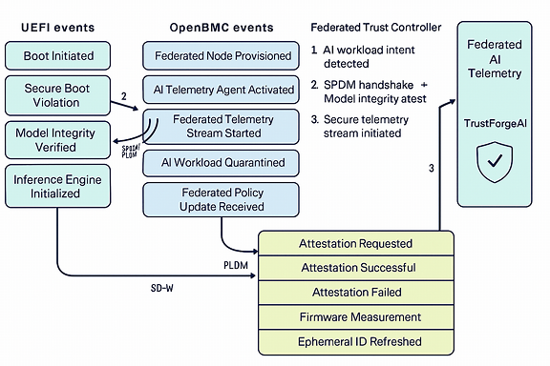
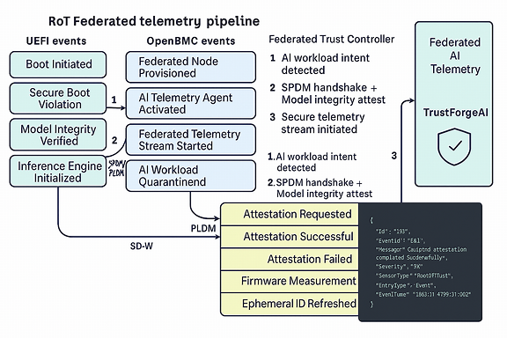

Redfish Schema Extension for RoT Events
To log Caliptra RoT events in OpenBMC and expose them via Redfish, we extend the LogEntry schema under LogServices/EventLog/Entries.

🔧 Extended Redfish LogEntry Fields
json
{
"@odata.type": "#LogEntry.v1_10_0.LogEntry",
"Id": "123",
"EventId": "FA01",
"Message": "Caliptra attestation completed successfully",
"Severity": "OK",
"SensorType": "RootOfTrust",
"EntryType": "Event",
"EventTime": "2025-11-04T09:51:00Z",
"AdditionalDataURI": "/redfish/v1/TelemetryService/Reports/CaliptraDigest123",
"Oem": {
"TrustForgeAI": {
"RoTDigest": "abc123...",
"EATToken": "eyJhbGciOiJFUzI1NiIsInR5cCI6IkVhdCJ9...",
"Nonce": "xyz789",
"VerificationStatus": "Verified"
}
}
}

🧩 Key Additions
- SensorType: RootOfTrust — tags RoT-originated events
- AdditionalDataURI — links to telemetry or attestation report
- Oem.TrustForgeAI — OEM extension for federated trust metadata
This structure supports Caliptra attestation, digest verification, and telemetry anchoring in federated AI environments.

🧠 Visual Integration Flow
The diagram above shows how RoT events flow from Caliptra → OpenBMC → Redfish → Federated Trust Controller:
- Caliptra emits ephemeral events (attestation, digest, identity)
- OpenBMC logs events via D-Bus and Redfish, tagging them with RoT metadata
- Federated Trust Controller ingests logs, verifies EAT tokens, and activates telemetry stream
This enables secure, standards-aligned observability for AI workloads across distributed nodes.

Events Storage:
Event Type | Generated By | Stored In | Notes
Firmware measurements | Caliptra | Passed to BMC or host via SPDM | Not stored locally in Caliptra
Attestation success/failure | BMC | Logged via D-Bus or Redfish | Based on SPDM/EAT verification
Identity binding / provisioning | BMC | Logged in OpenBMC event log | May include UUID, nonce, digest
RoT health status | Caliptra → BMC | Logged periodically or on fault | BMC polls or receives status
Ephemeral key rotation | Caliptra | Logged by BMC if policy requires | Useful for federated trust rotation

Component-Level Flow:
- Host CPU, GPU, Smart Memory → BMC, PCIe/CXL → Platform RoT → AI Orchestrator
Stages:
- Local collection
- Secure transport
- Aggregation
- AI analysis
- Policy enforcement
15. Hardware Requirements
🧠 AI Model Requirements for Federated Learning with RoT
Federated AI typically avoids large centralized models like GPT-style LLMs. Instead, it uses:
✅ Model Types
- Lightweight neural networks (e.g., CNNs, RNNs, small transformers)
- Quantized models for edge inference (e.g., MobileNet, TinyML)
- Split learning or vertical federated models for privacy-preserving collaboration
- Confidential federated learning (CFL) models that run inside secure enclaves
These models are trained across distributed nodes and aggregated securely, often using differential privacy or homomorphic encryption.
15.1 🔐 CPU and RoT Requirements
To support PSA Certified Level 2 or 3 and federated AI, the CPU inside the RoT must offer:
✅ Trusted Execution Environment (TEE)
- Arm TrustZone (for Cortex-A or Cortex-M) or equivalent
- Intel SGX, AMD SEV, or RISC-V PMP for secure memory isolation
- Microsoft Pluton for integrated TPM and firmware update resilience
✅ Cryptographic Acceleration
- Hardware support for AES, SHA, ECC, RSA, and optionally PQC
- Enables secure model aggregation, telemetry signing, and attestation
✅ Secure Boot and Firmware Update
- ROM-based bootloader with signature verification
- PSA Firmware Update API compliance
- Rollback protection and version control
✅ Attestation Engine
- Support for Entity Attestation Token (EAT) or CBOR Web Token (CWT)
- Enables remote trust validation of model execution and telemetry
✅ Secure Storage
- Isolated flash/NVM for model weights, credentials, and logs
- PSA Secure Storage API compliance
🧱 Example CPU Architectures
Architecture | RoT Feature Support | Use Case
Arm Cortex-M with TrustZone | PSA Level 2/3, Secure Storage, Crypto | IoT, edge nodes
Intel SGX | Enclave-based model execution | Cloud aggregation
AMD SEV | VM-level isolation | Federated training in data centers
RISC-V with PMP + Caliptra | Modular RoT, open-source attestation | Custom silicon, automotive
Microsoft Pluton | TPM 2.0, firmware resilience | Windows endpoints, AI PCs

16. Conclusion and Next Steps
This architecture bridges static RoT enforcement with dynamic, AI-driven runtime security. By embedding AI across bare metal components and coordinating via SPDM, TDISP, and telemetry, cloud platforms can achieve scalable, adaptive trust.
Next Steps:
- Develop proof-of-concept modules
- Standardize telemetry schemas
- Publish reference implementations
- Engage ecosystem partners for validation

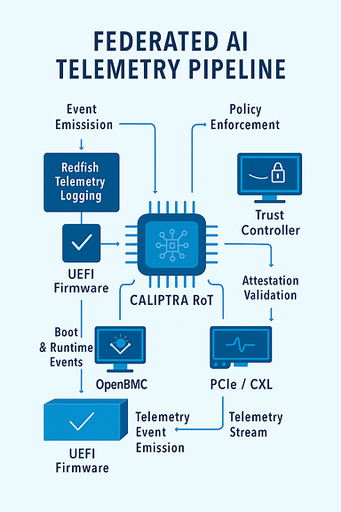
Telemetry-Diagram

